Week 5 ELA: May 5th

TIME | MONDAY | TUESDAY | WEDNESDAY | THURSDAY | FRIDAY
20 minutes  IREADY | IReady-  Click on the link below to get your minutes!  IREADY | IReady-  Click on the link below to get your minutes!  IREADY | IReady-  Click on the link below to get your minutes!  IREADY | IReady-  Click on the link below to get your minutes!  IREADY | IReady-  Click on the link below to get your minutes!  IREADY
20 minutes  Independent reading - choose from one of the two reading websites and explore books independently. | Get Epic!  Storyline  Scholastic Learn at Home  Scholastic Literacy Pro | Get Epic!  Storyline  Scholastic Learn at Home  Scholastic Literacy Pro | Get Epic!  Storyline  Scholastic Learn at Home  Scholastic Literacy Pro | Get Epic!  Storyline  Scholastic Learn at Home  Scholastic Literacy Pro | Get Epic!  Storyline  Scholastic Learn at Home  Scholastic Literacy Pro
20 minutes  Reading Lesson | ASSIGNMENT DUE IN TEAMS TODAY  Please try and log into your teams account and go to assignments each day and complete and turn in on teams | ASSIGNMENT DUE IN TEAMS TODAY  Please try and log into your teams account and go to assignments each day and complete and turn in on teams | Watch video below :  how to compare and contrast using a Venn Diagram | ASSIGNMENT DUE IN TEAMS TODAY  Reread nonfiction and fiction text and compare and contrast using the venn diagram  Venn diagram  Please try and log into your teams account and go to assignments each day and complete and turn in on teams | Fun Friday! Listen to this fun story!  zombies don't eat veggies!
Writing  30 minutes | Practice your typing!  Typing game | FREE WRITE-  You may write about whatever you would like. It could be a fiction, made up story. It could be writing about someone in your family or a pet. It could be writing about the changes with everything going on right now.  It is your choice! | 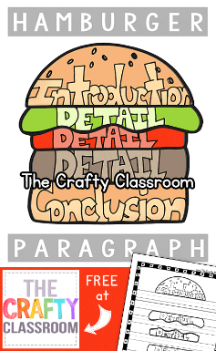  Let’s review writing a paragraph this week.  I put a visual of a hamburger to help you remember about paragraphs. There should be five sentences. There should be an introduction or opening sentence. There should be a closing or conclusion sentence. | 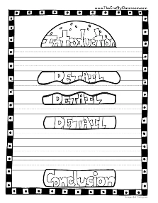Choose someone you are at home with. Write a paragraph about them.  Use the hamburger template to help you. | Choose your favorite activity. Anything fun you like to do!! Write a paragraph about it.  Use the hamburger template to help you.

